

From Greeting to Healing: Leveraging Hypnosis Principles for Effective Rapport Building in First Responder Communication
Understanding how patients can be assumed to be in a spontaneous hypnotic state can be a lifesaving tool for EMS providers.
Bram Duffee, PhD, EMT-P10.11.2023
Share

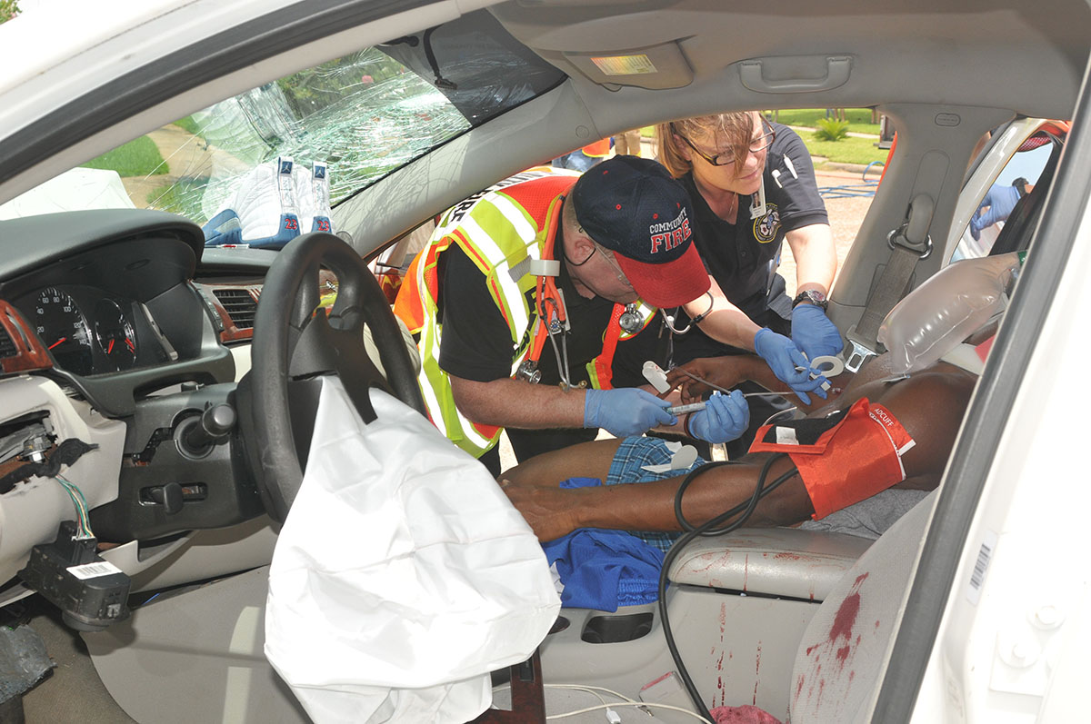
Photo/Lauralee Veitch, Community Volunteer Fire Department
A professional first responder can generally assume that in a serious medical emergency most patients are frightened to some degree. They might even be worried that they are dying. This acute stress can lead to various reactions, including trying to detach oneself from the situation, perceiving a dreamlike state, and having difficulty recalling or explaining details.¹
First responders deal with such patients regularly, however, many do not realize how this level of fearful stress puts individuals into state of spontaneous hypnosis that makes them acutely hyper-suggestible to the words of a perceived trusted authority figure, such as a uniformed professional first responder.
Thus, communicating effectively with patients who are experiencing fear and distress can present a unique opportunity for first responders. These patients, particularly in emergency situations, can often be overwhelmed by their emotions of fear, making it difficult to establish effective communication and provide the necessary care.²

Fear
The fear experienced by these patients can frequently result in a state of heightened vulnerability to activate a hypnotic trance. This is not coincidental, as fear can indeed induce such a state. Recognizing this can provide valuable insights into how to approach and communicate with these patients. The medic’s words can, if delivered appropriately, direct the patient’s autonomic nervous system to positively affect many vital functions such as blood pressure, heart rate, and pain response.³
While professional EMTs or paramedics should not see themselves as hypnotherapists, understanding how patients can be assumed to be in a spontaneous hypnotic state can be lifesaving.⁴ David Cheek, a physician who was a key figure in the development of psychosomatic medicine, asserted that severely ill patients do not require formal induction to enter a hypnotic trance.⁵
This assertion is supported by the work of Herbert Spiegel from Columbia University and David Spiegel from Stanford University, both respected psychiatrists specializing in hypnosis. They have extensively studied the effects of fear on the human mind and its potential to induce a hypnotic state.⁶
Gaining insight into the fact that a significant number of my own patients are in a state of hypnotic trance has reshaped my communication strategy as a paramedic. It’s crucial to recognize the profound importance of ensuring their psychological well-being and safety. I am mindful by shielding them from any harmful or negative comments from others, and I make it a point to communicate with affirmations about healing and improvement.

A Game-Changer
The way we engage with our patients can be a game-changer in cultivating a therapeutic alliance. It all begins with building a foundation of trust and esteem. This understanding has not only enhanced my approach but also reinforced the significance of patient-centered care in the healing process.
This topic is of special importance to me because of a patient encounter I had early in my career. I was summoned to help an elderly gentleman suffering from chest pains, and I knew he needed to seek immediate medical treatment for a probable heart attack. He was scared and it showed off in a way like he was in denial and refused to believe my words of concern. I could not convince him to go to the hospital.
Looking back, I realize that my communication was too brusque, and my words did not get through to him. I pushed in a commanding way about what was bad going on and should have pushed in a positive way as his partner who was there to help. Instead of transporting his living body to the hospital that day, he died. I found out because I was the one who also got called out the following day to pronounce him dead. This made me think about how I might modify my communication abilities so that I could be a better paramedic.
Once professional first responders hear about this phenomenon of spontaneous hypnosis in their patients, many intuitively recognize how it might be true.⁷ The first responder’s first words are vital and can harm or heal depending on what is said to the patient .⁴ Before speaking about the situation at hand or about the medical treatment that will be required, the first responder should introduce themselves and communicate that they are there to help.
This helps to build the trust of the patient and empowers the first responder. From there, they should inquire about the name of the patient. If the patient cannot speak or struggles to answer, the first responder should try to acquire this information from someone else who is at hand. By calling a patient by their name, it can help ensure that the patient does not feel helpless. In turn, this benefits the rapport the first responder is working to establish.

For Example
“Hi, I’m Darryl from the City’s emergency services, and I am here to help you. What’s your name?”
“Good evening, Darlene, my name is Rachel and I am a paramedic. I’m here to make sure you’re okay. Will you let me help you? (Receive acknowledgment.) We will work together to get you back on the road to recovery.”
“Hi, Mrs. Jones. My name is Adam, and I’m an EMT with 15 years in the field. I’m here to help you feel better. Could you partner with me to assure your care will lead to the most positive outcomes? (Receive acknowledgment.) That’s great!”

First Impressions
Such rapport building begins before the interaction commences. First impressions are crucial. If the patient is put off by your look manner or tone, the medical interaction is off to a poor start. First responders need to offer a mood of seriousness and kindness. The patient needs to know that the first responder is focused on helping and that they are also a caring human being. It is good to offer a sympathetic smile while making sure to not seem too cheerful during this moment of stress. Showing authentic kindness lets the patient know that a real person is there to help and can be worked into the interview and treatment conversations.⁸
It is also useful for establishing rapport to start out by clearly articulating your role. This not only establishes your competence and expertise but also assures the patient of your ability to guide them through their recovery journey. This can build cooperation and trust between you and the patient.
Highlighting the significance of the patient’s personal efforts in their recovery process is crucial. By doing so, you empower them to take an active role in their own treatment plan. This step reinforces their willingness to accept your help. Giving patients a sense of autonomy aligns with the Self-Determination Theory. According to this theory, individuals who feel they are acting freely are more likely to accomplish their goals, including those related to health.⁹
The significance of words during an emergency have been underscored, particularly in relation to the mind-body connection observed during hypnosis. However, in my interpersonal communication and public speaking classes, I always teach that communication extends beyond mere words. This is true even with a patient who is in a hypnotic trance.
Indeed, we are constantly transmitting messages or emotions like fear or frustration through our body positioning, vocal tone, appearance, and touch.¹⁰ As such, it is crucial for first responders to be mindful of the nonverbal cues they project, ensuring the patient remains the focal point of the interaction.

Another Example
For instance, upholding a serene facial expression even amidst a high-stress scenario can alleviate patient anxiety and bolster reassurance. The use of open-handed gestures can signify a readiness to assist, fostering a sense of comfort in the patient. Maintaining eye contact is a potent demonstration of attentiveness, signaling to the patient that they are your immediate priority.
A soothing touch, like a gentle pat on the back, can serve as a comforting gesture, providing assurance to the patient. Even a professional appearance exudes competence and reliability, further instilling confidence in the patient regarding the first responder’s capacity to efficiently manage the situation.¹¹
Although just a brief introduction, this article brings to light the critical importance of effective communication in emergency medical scenarios. It introduces the innovative idea that patients enter a trance-like state during high-fear situations, highlighting the need for first responders to display empathy, build rapport swiftly, and give appropriate hypnotic directives as an adjunct to standard medical care, while avoiding negative and possibly harmful words.
The importance of a patient-centric approach is underscored through a case study, illuminating the potential consequences of inadequate communication. For professionals in the field, this provides a fresh perspective and actionable strategies for improving patient interactions. Further information about using techniques related to hypnosis with patient communication can be found in my co-authored book “Hypnotic Communication in Emergency Medical Settings: For Life-saving and Therapeutic Outcomes.”³

References
1. Bryant, R., & Harvey, A. (2000). Acute stress disorder: A handbook of theory, assessment, and treatment. Washington, D.C.: American Psychological Association.
2. Dick, T. (2010, July 31). Ease Patient’s Fear for Better Care. JEMS Journal of Emergency Medical Services. https://www.jems.com/operations/ease-patient-s-fear-better-car/
3. Jacobs, D.T., & Duffee, B. (2023). Hypnotic communication in emergency medical settings: For life-saving and therapeutic outcomes. Routledge.
4. Acosta, J. & Prager, J. (2002). The Worst is Over: What to Say When Every Moment Counts. San Diego, CA: Jodere.
5. Cheek, D. B., (1969) Communication with the Critically Ill, American Journal of Clinical Hypnosis, 12:2, 75-85, DOI: 10.1080/00029157.1969.10734309
6. Spiegel, H., & Spiegel, D. (2008). Trance and treatment: Clinical uses of hypnosis. American Psychiatric Pub.
7. Moates, M. (2022). Trauma-Patient Communication: First Responder Perspectives
On Utilizing Spontaneous Hypnosis as an Adjunct to Standard Emergency Medical Care. [Dissertation] Fielding Graduate University.
8. Riess, H., & Kraft-Todd, G. (2014). EMPATHY: a tool to enhance nonverbal communication between clinicians and their patients. Academic Medicine, 89(8), 1108-1112.
9. Ryan, R. M., & Deci, E. L. (2017). Self-determination theory: Basic psychological needs in motivation, development, and wellness. New York: Guilford Publishing.
10. Snowdon, K. (2019). Fear in the paramedic clinical environment. Journal of Paramedic Practice, 11(7), 1-6.
11. Willis, S., & Mellor, G. (2014). Communication skills for the pre-hospital professional. Fundamentals of paramedic practice: A systems approach.

